VAJE K LEKCIJI VEZAVA IN POLVEZAVA

Hvala Arja – Mlakar Matej, 2015 p Kralj Samo – Tisaj Domen, 2015 p
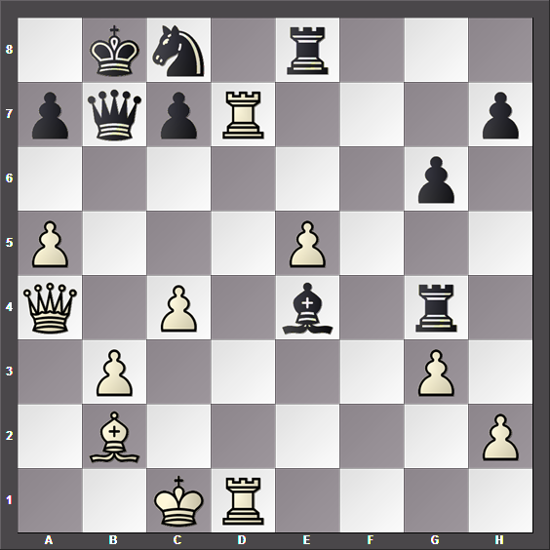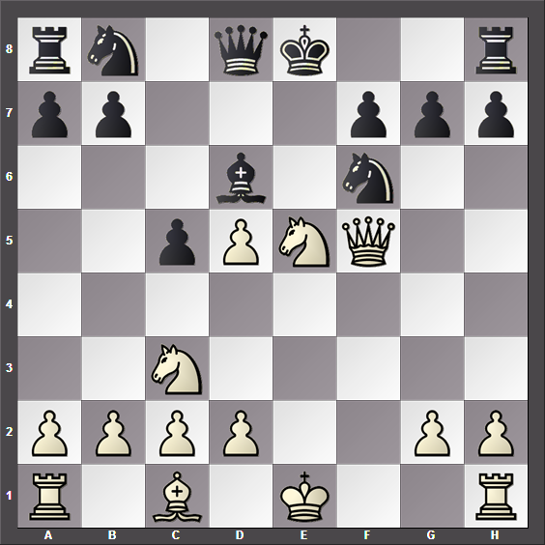

Dolinar Matic – Anže Novak, 2015 p Debevec Katarina – Tišler Jan, 2015 p
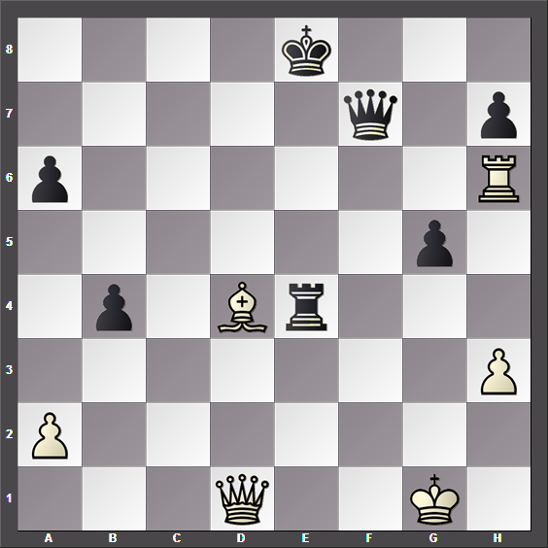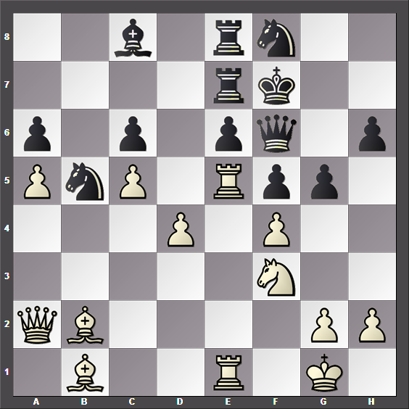

Malkoč Patrik – Hvala Arja Ela, 2015 p Jereb Lana – Hribar Andrej, 2015 p
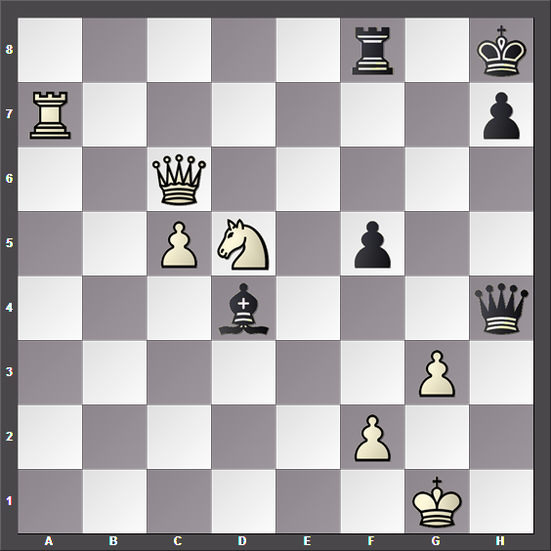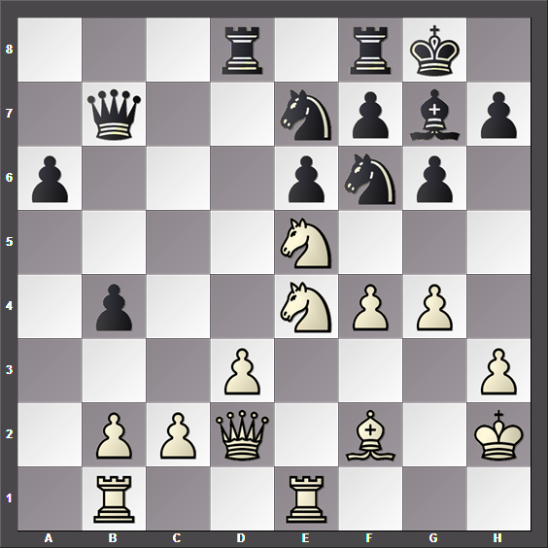

Marn Jan – Tisaj Domen, 2015 pp Hvala Arja Ela – Mlakar Matej, 2015 pp
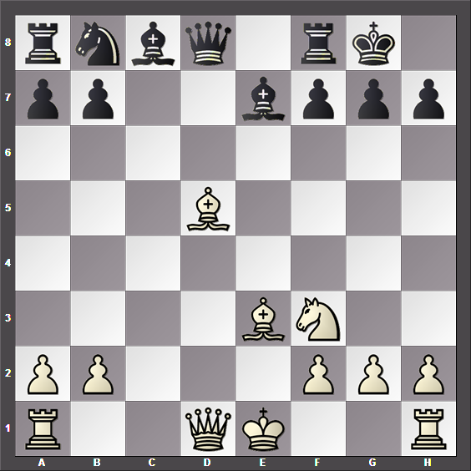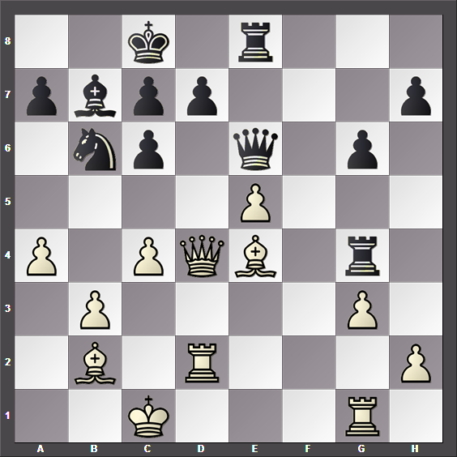

Ragozin – Boleslavski, 1945 pp pp
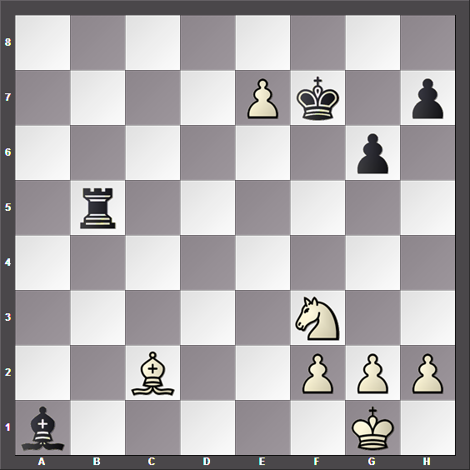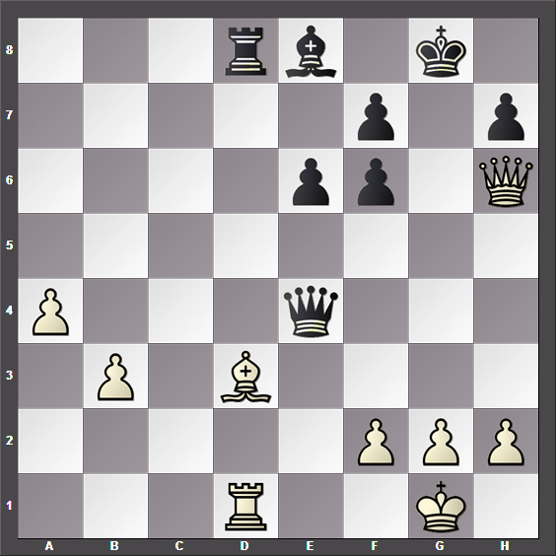

pp pp
